Zomato restaurant analysis
- What is the total no. of tables present in the data?
Ans : The dataset contains two distinct tables; each located in a separate sheet:
- "Raw Data" Sheet:
This is the main table with detailed information on restaurants—covering aspects like restaurant names, city, ratings, cuisines, average cost, and more. It serves as the core dataset for any analysis.
- " Country description raw" Sheet:
This sheet provides a reference table that maps country codes to their corresponding country names. It acts as a lookup table that supports the main dataset.
So, the total number of tables present in the data is two, with each playing a unique role in offering complete analytical context
- What is the total no. of attributes present in the data?
- Ans: The dataset contains a total of 20 attributes in the "Raw Data" sheet and 2 attributes in the "Country description raw" sheet.
So, there are 22 attributes in total across both sheets.
- How many categorical columns are there in the data? [Search about categorical and continuous data, and try to answer this question]
- Ans: There are 14 categorical columns in the "Raw Data" sheet:
- Restaurant ID
- Restaurant Name
- Country Code
- City
- Address
- Locality
- Locality Verbose
- Cuisines
- Currency
- Has_Table_booking
- Has_Online_delivery
- Is_delivering_now
- Switch_to_order_menu
- Price_range

- There are 2 categorical columns in the "Country description raw" sheet:
- Country Code
- Country

- The data consists of some inconsistent and missing values so ensure that the data used for further analysis is cleaned.
Ans: To prepare the dataset for analysis, the following data cleaning steps were performed:
- Handled rows with missing values in the Cuisines column
  - Logic: Applied a filter on the Cuisines column, identified the blank entries, and filled this cell with unknown.
- Trimmed extra spaces and mangage in a Proper from all data.
  - Formula: =TRIM(cell) Formula:=PROPER(cell)
- Filled missing values in Average Cost for two
  - Logic: All “0” values were in Price_range category "1", so the median of this category was calculated and used to fill the gaps.
- Converted the Date key opening column from string format to proper date format.
- Extracted Year and Month from the converted date
  - Year: =TEXT(cell, "yyyy")
  - Month: =TEXT(cell, "mmmm") for full month names

These cleaning actions helped make the dataset more structured and analysis-ready. I kept the given raw data as it is rather created another worksheet “Raw Data (2)” and have done all above changes to this sheet.
. Added new columns:
  - Country from CountryCode
  - Symbol and ISO Code from Currency
  - Avg_cost_with_symbol and Avg_cost_for_two(INR) using Average_Cost_for_two
  - Price category, Average cost category, Cost per Rating, Popularity, Price Category.

- Using the Lookup functions, fill up the countries in the original data using the country code.
Ans : To populate the Country names based on the Country Code, a VLOOKUP function was applied in the "Raw Data (2)" sheet.
- A new column named Country was added in the "Raw Data (2)" sheet.
- The formula used to retrieve the country names from the "country description" sheet was: =VLOOKUP($C2, 'country description'!$A$1:$B$16, 2)
- Explanation:
  - $C2 refers to the Country Code in the current row of the "Raw Data (2)" sheet.
  - 'country description'!$A$1:$B$16 is the lookup table containing country codes and their corresponding country names.
  - 2 indicates that the country name will be fetched from the second column of the lookup range.
This formula was applied throughout the column to fill in all the corresponding country names accurately.

- Create a table to represent the number of restaurants opened in each country.
Ans: To find out how many restaurants are opened in each country, a Pivot Table was created using the data from the "Raw Data (2)" sheet.
- Selected all the data in the "Raw Data (2)" sheet.
- Went to Insert → Pivot Table and chose the location to place the Pivot Table.
- Added the Country field to the Rows section and the Restaurant ID field to the Values section, then changed the summary function to Count to display the number of restaurants.
- Also created a chart for better visualization.
Country | No. of Restaurant
Australia | 24
Brazil | 60
Canada | 4
India | 8652
Indonesia | 21
New Zealand | 40
Philippines | 22
Qatar | 20
Singapore | 20
South Africa | 60
Sri Lanka | 20
Turkey | 34
United Arab Emirates | 60
United Kingdom | 80
United States of America | 434
Grand Total | 9551

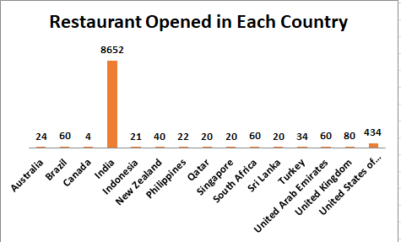
- Also, the management wants to look at the number of restaurants opened each year, so provide them with something here.
Ans:
To help the management analyse how many restaurants were opened each year, a Pivot Table was created using the data from the "Raw Data (2)" sheet.

- Selected all the data in the "Raw Data (2)" sheet.
- Clicked on Insert → Pivot Table and selected the location for the Pivot Table.
- Added the Year field (from the newly created column) to the Rows section, and the Restaurant ID field to the Values section. Then, changed the summary function to Count to display the number of restaurants.

Year | No. of Restaurant
2010 | 1080
2011 | 1098
2012 | 1022
2013 | 1061
2014 | 1051
2015 | 1024
2016 | 1027
2017 | 1086
2018 | 1102
Grand Total | 9551

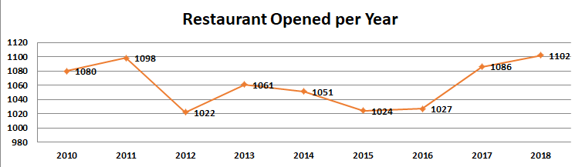
- What is the total number of restaurants in India in the price range of 4?
Ans: To determine the total number of restaurants in India with a price range of 4, the COUNTIFS function was used.
The formula used:
=COUNTIFS('Cleaned Data'!D2:D9552, "India", 'Cleaned Data'!M2:M9552, "=4")
. The result is 388, indicating there are 388 restaurants in India with a price range of 4.
- What is the average number of voters for the restaurants in each country according to the data?
Ans: To calculate the average number of voters for restaurants in each country, a Pivot Table was created using the data from the "Raw Data (2)" sheet.

- Selected all the data in the "Raw Data (2)" sheet.
- Went to Insert → Pivot Table and selected the location for the Pivot Table.
- Added the Country field to the Rows section and the Votes field to the Values section. Then changed the summary function to Average to get the average number of voters per country.

Country | Average of Votes
Australia | 111
Brazil | 20
Canada | 103
India | 137
Indonesia | 772
New Zealand | 243
Philippines | 407
Qatar | 164
Singapore | 32
South Africa | 315
Sri Lanka | 146
Turkey | 431
United Arab Emirates | 494
United Kingdom | 205
United States of America | 428
Grand Total | 157
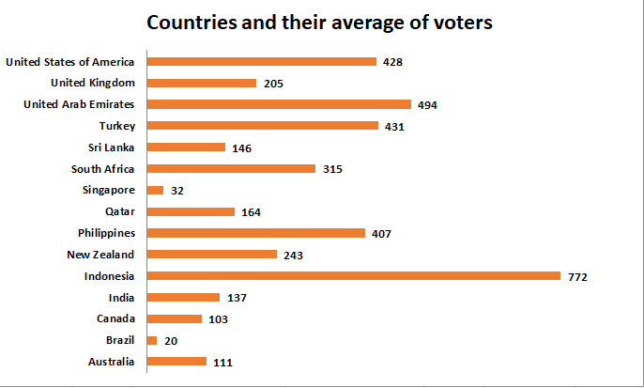

- Calculate the average rating for all the restaurants that have price_range < 4 and provide online delivery. Use only the “IF” function, Logical Operators, and Aggregation functions to solve this problem. [Note: Don’t use Conditional aggregation in this question.]
Ans:
The average rating for all the restaurants that have price_range < 4 and provide online delivery is 3.27.
The Formula used is:
=AVERAGEIFS('Cleaned Data'!Q:Q, 'Cleaned Data'!K:K, "Yes", 'Cleaned Data'!M:M, "<4")
- Create a new customized price column that consists of the abbreviation/symbol of the currency along with the Average_cost_for_two value. [Use string operations to do this task].
Ans:
To create a new column that displays the currency abbreviation along with the Average cost for two, a string operation formula was used in the "Raw Data (2)" sheet.

- A new column named Customized_Average_Cost_for_two was created.
- Formula used:
=IF(I2="Indian Rupees(RS.)", "₹",
- IF(I2="Dollar($)", "₹",
- IF(I2="Pounds(Œ£)", "₹",
- IF(I2="Brazilian Real(R$)", "₹",
- IF(I2="Turkish Lira(TL)", "₹",
- IF(I2="Qatari Rial(QR)", "₹",
- IF(I2="Rand(R)", "₹",
- IF(I2="Botswana Pula(P)", "₹",
- IF(I2="Sri Lankan Rupee(LKR)", "₹",
- IF(I2="Indonesian Rupiah(IDR)", "₹",
- IF(I2="Emirati Diram(AED)", "₹",
- IF(I2="NewZealand($)", "₹", "")))))))))))) & " " & P2

This formula extracts the currency abbreviation/symbol from the Currency column and combines it with the value from the Average_cost_for_two column
- Create a new customized price column that consists of the abbreviation/symbol of the currency along with the Average_cost_for_two value. [Use string operations to do this task]
Ans: To create a new column that displays the currency abbreviation along with the Average cost for two, a string operation formula was used in the "Clean Data " sheet.
formula used to create a new column(currency symbol column):
=IF(I2="Indian Rupees(RS.)", "₹",
IF(I2="Dollar($)", "₹",
IF(I2="Pounds(Œ£)", "₹",
IF(I2="Brazilian Real(R$)", "₹",
IF(I2="Turkish Lira(TL)", "₹",
IF(I2="Qatari Rial(QR)", "₹",
IF(I2="Rand(R)", "₹",
IF(I2="Botswana Pula(P)", "₹",
IF(I2="Sri Lankan Rupee(LKR)", "₹",
IF(I2="Indonesian Rupiah(IDR)", "₹",
IF(I2="Emirati Diram(AED)", "₹",
IF(I2="NewZealand($)", "₹", "")))))))))))) & " " & P2

- How can you create an array formula in Excel or Google Sheets to count the number of restaurants listed that do not offer online delivery, are in the lowest price range, and have an average cost for two people less than or equal to 250 Indian Rupees?

Solution:
To calculate the number of restaurants that do not offer online delivery, are in the lowest price range, and have an average cost for two people less than or equal to 250 Indian Rupees, the following array formula was used in the "Raw Data (2)" sheet:

- Formula used: {=COUNTIFS('Raw Data (2)'!P:P, "No", 'Raw Data (2)'!S:S, "1", 'Raw Data (2)'!W:W, "<=250")}
- This formula checks all three conditions simultaneously and returns the total count of rows matching the criteria.

Output: The final count is 1676, meaning there are 1676 restaurants meeting all three specified conditions.

SUBJECTIVE QUESTION

- Suggest a few countries where the team can open newer restaurants with lesser competition. Which visualization/technique will you use here to justify the suggestions?

Ans. To identify ideal countries for expansion, I began by analyzing where restaurant competition is low, but customer engagement and satisfaction remain promising. The idea was to find markets that are not yet saturated but show potential based on demand signals like ratings and voter count.
.Strategy and Criteria:
I focused on countries that met the following conditions:
. Fewer than 25 listed restaurants (indicating lower competition)
. Average rating ≥ 4 (showing strong customer approval)
. Coverage in 10+ cities (ensuring regional spread)
. More than 100 votes (signifying active customer participation)

Visualization:
To justify these recommendations, I used Pivot Tables to compare restaurant counts, average ratings, number of cities, and voter counts across countries.

Country | Average of Votes | Average of Rating | No. of Restaurant
Australia | 111.42 | 3.7 | 24
Brazil | 19.62 | 3.8 | 60
Canada | 103 | 3.6 | 4
India | 137.21 | 2.8 | 8652
Indonesia | 772.10 | 4.3 | 21
New Zealand | 243.03 | 4.3 | 40
Philippines | 407.41 | 4.5 | 22
Qatar | 163.8 | 4.1 | 20
Singapore | 31.9 | 3.6 | 20
South Africa | 315.17 | 4.2 | 60
Sri Lanka | 146.45 | 3.9 | 20
Turkey | 431.47 | 4.3 | 34
United Arab Emirates | 493.52 | 4.2 | 60
United Kingdom | 205.49 | 4.1 | 80
United States of America | 428.22 | 4 | 434
Grand Total | 156.9097477 | 2.89126793 | 9551

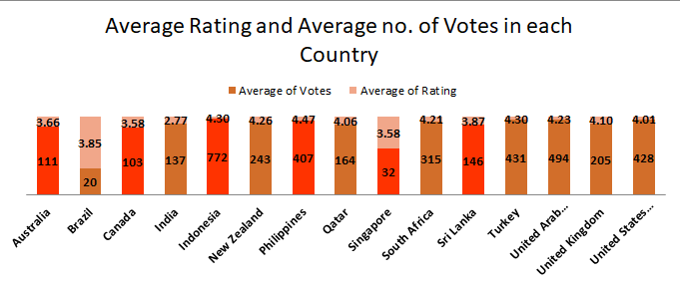

- Come up with the names of States and cities in the suggested countries suitable for opening restaurants.

Ans. After identifying the countries with promising potential for expansion, the next step was to pinpoint the specific states and cities within them. I focused on finding areas where competition is still low, but market conditions—such as pricing and customer satisfaction—are favorable for opening new restaurants.

Strategy and Criteria:
To select suitable locations, I followed a two-layered filter:
- State-level filter: Chose states with fewer than 4 restaurants listed, indicating lower saturation.
- City-level filter: From those states, selected cities where the average cost for two was close to the overall country’s average, suggesting affordability balanced with revenue potential.

Insights and Recommendations:
Here are the top recommended locations based on this strategy:

Suggested Country | State | Cities
Australia | Montserrado | Paynesville
 | Queensland | Flaxton, Montville, Palm Cove
 | Western Australia | Middleton Beach
 | South Australia | Tanunda
Canada | Alberta | Consort
 | Ontario | Vineland Station
 | Saskatchewan | Yorkton
Indonesia | Banten | Tangerang
 | West Java | Bandung, Bogor
Philippines | Cavite | Tagaytay City
 | Laguna | Santa Rosa
 | Metro Manila | Mandaluyong City, Pasay City, Taguig City
Sri Lanka | Western Province | Colombo

- According to the countries you suggested, what is the current quality regarding ratings for restaurants that are open there?

Ans. Based on the data analysis, the current quality of restaurants in the suggested countries is high to excellent, especially in cities with low competition (fewer restaurants). The suggested countries and cities have high average ratings and low restaurant density, making them ideal for new restaurant openings. The quality of current restaurants reflects high customer satisfaction, suggesting favourable conditions for investment and expansion.

Suggestion:
While Indonesia and the Philippines already show strong customer satisfaction, Canada, Australia, and Sri Lanka fall behind in terms of average ratings. These countries could benefit from offering online delivery, enabling table booking, and diversifying their cuisine offerings — steps that could significantly boost customer satisfaction and make them more promising for new restaurant ventures.

Visualization:
Country | Average of Votes | Average of Rating
Australia | 111 | 3.66
Canada | 103 | 3.58
Indonesia | 772 | 4.30
Philippines | 407 | 4.47
Sri Lanka | 146 | 3.87
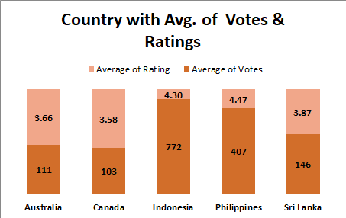

- Also, what is the current expenditure on food in the suggested countries, so we can keep our financial expenditure in control?

- Ans. I used a pivot table and chart to check the average food cost for two people in each of the suggested countries. This helped understand how much people usually spend on eating out.
Suggestion:
Sri Lanka and Indonesia are more affordable. We can open restaurants here with simple menus and good pricing to attract more people.
- Australia and Canada are mid-range. If we manage things smartly, like choosing the right location and keeping costs low; we can still make good profits.
- Philippines is expensive. Here, it’s better to go for a premium restaurant setup in popular cities where people are willing to spend more.

Visualization:

Country | Average of Average Cost of Two (INR)
Australia | 1366
Canada | 2056
Indonesia | 1490
Philippines | 9995
Sri Lanka | 683
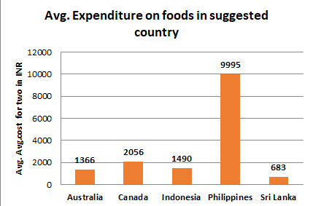

- Come up with the names of restaurants from the recommended states that are our biggest competitors and also those that are rated in the lower brackets, i.e. 1-2 or 2-3.

Ans. Biggest competitors (Top-rated, Avg. rating > 4.2). These restaurants are likely market leaders in quality and customer satisfaction.
Low-Rated Restaurants (Avg. Rating between 1 and 3).These Restaurants may represent weak competition or market gaps due to poor quality.

Country | Biggest competitors | Lowest ratings
Australia | Vivo Bar and Grill | Pier 70
 | 1918 Bistro & Grill | Poets Cafe
Canada | Lake House Restaurant | Consort Restaurant
Indonesia | Talaga Sampireun | Onokabe
 | Lemongrass | Momo Milk
 | Noah's Barn Coffeenery
Philippines | Balay Dako | Cafe Arabelle
 | Nonna's Pasta & Pizzeria
Sri Lanka | Arabian Knights | Elite Indian Restaurant
 | Burger's King | Queen's Cafe
 | Butter Boutique
 | Cafe Beverly
 | Carnival Ice Cream
 | Cricket Club Cafe
 | Ministry of Crab
 | Simply Strawberries By Jagro
 | T.G.I. Friday's
 | The Commons
 | The Manhattan FISH MARKET
 | The Sizzle
 | Upali's

Suggestion:
- High-rated restaurants show that customers value quality, ambience, and consistent service. Competing in such markets means we need to offer something unique—like signature dishes, cozy interiors, or seamless service.
- On the other hand, the low-rated restaurants reveal gaps in the market. These are opportunities. By avoiding their mistakes—like poor customer handling or slow service—we can step in and win over their dissatisfied customers. So, with thoughtful planning and customer-first thinking, we can confidently enter and grow in these regions.

- Which cuisines should we focus on in the newer restaurants to get better feedback? Does the choice of cuisines affect the restaurant ratings?

Ans. After analysing the data we have found some cuisines to suggest for new restaurant to get good feedback.
Approach:
average rating must be > 4.2 and have a decent vote.
visualisation:
Countries | Suggested Cuisines
Australia | Mediterranean, Seafood
 | Modern Australian, Australian
 | Pizza, Bar Food
Canada | Italian, Mediterranean, Pizza
Indonasia | Asian, Indonesian, Western
 | Burger
 | Cafe, Coffee and Tea, Western
 | Cafe, Desserts, Beverages
 | Cafe, Italian, Coffee and Tea, Western, Indonesian
 | Cafe, Western
 | Desserts, Bakery, Western
 | Japanese, Sushi, Ramen
 | Sunda, Indonesian
 | Sushi, Japanese
Phillipines | American, Asian, Italian, Seafood
 | Cafe, Bakery, American, Italian
 | European, Asian, Indian
 | Filipino
 | Filipino, Mexican
 | Japanese
 | Japanese, Sushi
 | Seafood, American, Mediterranean, Japanese
Srilanka | Juices, Desserts
 | Seafood

Suggestion:
Cuisines like Mediterranean, Seafood, Pizza, Bar Food, Italian, Mediterranean, Pizza, Japanese, Sushi, Ramen, Cafe, Italian, Coffee and Tea, Western, Indonesian, and Filipino, Mexican consistently receive high ratings and strong vote counts across countries.
- Cafe, Coffee and Tea, Western, Desserts, Bakery, Western, and Juices, Desserts also perform well, especially in Indonesia and Sri Lanka.
- In contrast, cuisines with broader or less specific combinations, such as Asian, Modern Australian, and North Indian, Chinese, Sri Lankan, tend to receive lower ratings and fewer votes in the suggested countries.

- According to our current data, should we go for online delivery and table booking? Does that affect the customer’s ratings?

Ans. To analyze the impact of online delivery and table booking on customer ratings, I created a pivot table with these two factors in the Rows and Columns section, and the average of ratings in the Values section.
I also added a country filter to compare results across different regions, especially focusing on the countries selected for expansion.
This was further visualized using a chart for a clearer view of rating variations.

Visualization:

Average of Rating | Has_Online_Delivery
Has_Table_Booking | No | Yes | Grand Total
No | 2.68 | 3.22 | 2.81
Yes | 3.41 | 3.60 | 3.48
 | 2.75 | 3.29 | 2.89
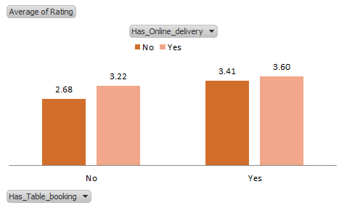
Insights:
- The suggested countries for expansion currently do not offer online delivery.
- In countries where online delivery and table booking are available, both ratings and vote counts are observed to be higher.
- For instance, in India, the average rating for restaurants with online services is 3.6, compared to 2.5 for those without.
- This trend indicates a positive correlation between offering online services and receiving better customer feedback.

- Should the team keep the rate of cuisines higher? Will that affect the feedback? According to our data are the rates of cuisines and ratings, correlated?

Ans. Approach:
To evaluate if cuisine pricing affects customer feedback, I analyzed the suggested cuisines and extracted the maximum and minimum prices, along with the corresponding average ratings.

- Formula for maximum price: as example
=MAXIFS('Raw Data (2)'!$W$2:$W$9542, 'Raw Data (2)'!$L$2:$L$9542, 'Subjective questions'!A328)
- Formula for minimum price:
=MINIFS('Raw Data (2)'!$W$2:$W$9542, 'Raw Data (2)'!$L$2:$L$9542, 'Subjective questions'!$A328)
- Used AVERAGEIFS to calculate ratings at both price extremes.

Suggested Cuisines |  | Max. Price | Max. Rating | Min. Price | Min. Rating
Mediterranean, Seafood |  | 2574 | 4.4 | 2574 | 4.4
Modern Australian, Australian |  | 2574 | 4.4 | 2574 | 4.4
Pizza, Bar Food |  | #### | 3.6 | 1715 | 4.6
Italian, Mediterranean, Pizza |  | 6006 | 4.3 | 2145 | 4.1
Asian, Indonesian, Western |  | 4240 | 4.6 | 4240 | 4.6
Burger |  | 3432 | 4.45 | 636 | 4.4
Cafe, Coffee and Tea, Western |  | 795 | 4.2 | 735 | 4.2
Cafe, Desserts, Beverages |  | 371 | 3.7 | 371 | 3.7
Cafe, Italian, Coffee and Tea, Western, Indonesian |  | 875 | 4.6 | 874.5 | 4.6
Cafe, Western |  | 1590 | 4.3 | 1590 | 4.3
Desserts, Bakery, Western |  | 1060 | 4.6 | 1060 | 4.6
Japanese, Sushi, Ramen |  | 1060 | 4.4 | 1060 | 4.4
Sunda, Indonesian |  | 1060 | 4.9 | 1060 | 4.9
Sushi, Japanese |  | 2650 | 4.9 | 1882.8 | 3.5
American, Asian, Italian, Seafood |  | 11592 | 4.5 | 11592 | 4.5
Cafe, Bakery, American, Italian |  | 9660 | 4.4 | 9660 | 4.4
European, Asian, Indian |  | #### | 4.9 | 38640 | 4.9
Filipino |  | 7728 | 4.5 | 6440 | 4.2
Filipino, Mexican |  | 5152 | 4.85 | 5152 | 4.85
Japanese |  | 7728 | 4.5 | 858 | 4.6
Japanese, Sushi |  | 11640 | 4.4 | 1100 | 3.4
Seafood, American, Mediterranean, Japanese |  | 19320 | 4.7 | 19320 | 4.7
Juices, Desserts |  | 371 | 4.5 | 300 | 3.5
Seafood |  | 6006 | 4 | 500 | 4.2

Then, I created a scatter chart to visualize the relationship between prices (max and min) and ratings.

Visualization:
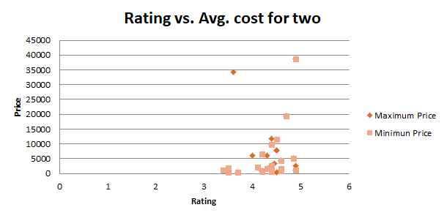

After observing the chart, I calculated the correlation coefficient to check the strength of this relationship using:
=CORREL(E339:E363,G339:G363
Insights:
- The chart showed that both max and min-priced cuisines received good ratings, indicating no strong visual pattern.
- The correlation coefficient came out to be 0.289049328, which confirms a weak positive relationship between pricing and ratings.
- This means that simply increasing cuisine prices does not significantly improve customer feedback.

Suggestion:
- Ratings are not driven by price alone. Customers care more about value, taste, and the overall dining experience.
- Therefore, instead of focusing on higher pricing, we should aim to offer a well-balanced experience, one that justifies the price through service, quality, and ambiance.

- What is the distribution of the number of restaurants of different price ranges in all the countries?
Ans. A pivot table was created using Price Range in the row section and Count of RestaurantID in the values section. A country slicer was added to filter the data and view the distribution by region. This setup enables a clear analysis of how restaurants are spread across different pricing categories, and the slicer allows easy comparison across countries.

Price range | Count of Restaurant ID
1 | 4444
2 | 3113
3 | 1408
4 | 586
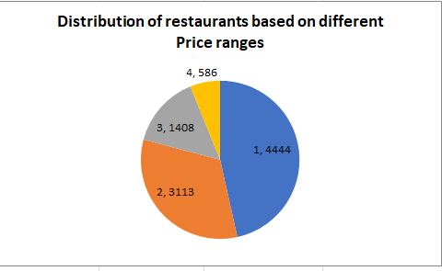

Insights:
- The majority of restaurants fall under Price Range 1, with 4,438 restaurants, indicating a strong focus on budget-friendly dining options.
- Price Range 2 also has a significant presence with 3,113 restaurants, suggesting a decent share of mid-range offerings.
- Higher-end restaurants, i.e., Price Range 3 and 4, are less common with only 1,406 and 586 restaurants, respectively.
Output:
This distribution clearly shows that affordable dining is the most common, with the majority of restaurants falling under price range 1 and 2. This suggests that most customers prefer budget-friendly options. On the other hand, premium dining (price range 3 and 4) is much less common, indicating it’s a niche market with fewer players but possible room for growth in select areas.

- Explain your approach in brief for suggesting countries/cities in order to open new restaurants, if the objective and subjective questions would have not been given to assist you. [you have to give bullet pointers in order to answer this question].
Ans. Approach for Suggesting Countries/Cities (Without Given Questions)
- Clean and prepare the dataset (remove duplicates, fix missing values, standardize fields).
- Analyze market size by counting restaurants per country/city to find supply gaps.
- Identify high-rating regions for strong customer satisfaction potential.
- Study cuisine popularity and spot underserved cuisines for entry.
- Compare price ranges vs. ratings to choose correct pricing strategy.
- Map competitors and look for high-demand but low-competition markets.
- Score and rank locations based on demand, competition, pricing, and ratings.

